**HOME SERVICES PROVIDER WEBSITE**

**UCS662 Test Automation Project Report**

1. **Introduction**

The website will act as one place for various home services. This website welcomes two types of users. One is Seeker (who seeks service as per their requirement) and the other is Provider (who provides home services related info to the seeker as per demand). If one already has an account then do log in else if an account does not exist then go to the sign-up page for your account. The sign-up pages open with two options one for the seeker and other for the provider. If you are a seeker then proceed by filling in your basic details in the form provided like address, phone no., city, etc. and if you are a provider then provide your basic information along with your professional data. In professional data, the provider has to add a profile picture, services they provide, availability time, and the particular services they are registering for.

After signing up, a page will open for the Seeker where they can explore various services like electrician, plumber, carpenter, home painting, blacksmith, cleaning and pest control, appliance repair, etc. based on the service chosen, further options that particular service will be displayed. After the complete selection of the service, a list of service providers will be displayed to the seeker which will be sorted based on the address of the seeker. In addition to this, the seeker can also sort the search results as per their city preferences.

After filling out the form as a Provider, an account will be created and a page will be displayed where the registered profile can be viewed. Further details can be added to the profile like services, images, bio, etc. which can be updated or changed in the future.

**2. Problem Statement**

Finding reliable home services like plumbing, electrical work, and repairs is challenging due to fragmented platforms and unclear provider information. Our solution is an integrated online platform that centralizes information about service providers, offering detailed profiles to help users make informed decisions. This solution aims to simplify the process of accessing and evaluating home service providers efficiently.

**3. Specific Requirements**

**a. Functional requirements**

User Authentication:

Users can either log in with existing credentials or sign up for a new account. Seekers and Providers have separate registration processes.

User Profile Creation:

Seekers provide basic details like address, phone number, and city. Providers provide basic information along with professional data, including profile picture, services provided, availability time, and upload valid proof documents.

Service Exploration for Seekers:

Seekers can explore various home services like electrician, plumber, carpenter, etc. Based on the selected service, further options are displayed. Seekers can filter search results based on their preferences, such as city.

Service Provider Listing:

After service selection, a list of service providers is displayed to the seeker. Providers are sorted based on the seeker's address. Seekers can view provider profiles for more information.

Provider Profile Management:

Providers can view and manage their profile. They can add/update details like services offered, images, bio, etc.

**b. Non-functional requirements**

Security:

Secure authentication mechanisms to protect user data. Encryption for sensitive information like passwords and personal details.

Scalability:

The system should be able to handle a growing number of users and service providers without performance degradation.

Performance:

Fast loading times for pages and search results to enhance user satisfaction. Efficient database queries to retrieve and display relevant information promptly.

Privacy:

Compliance with data protection regulations to safeguard user privacy. Options for users to control the visibility of their profile information.

**4. Data Flow Diagram**

* **DFD Level 0**

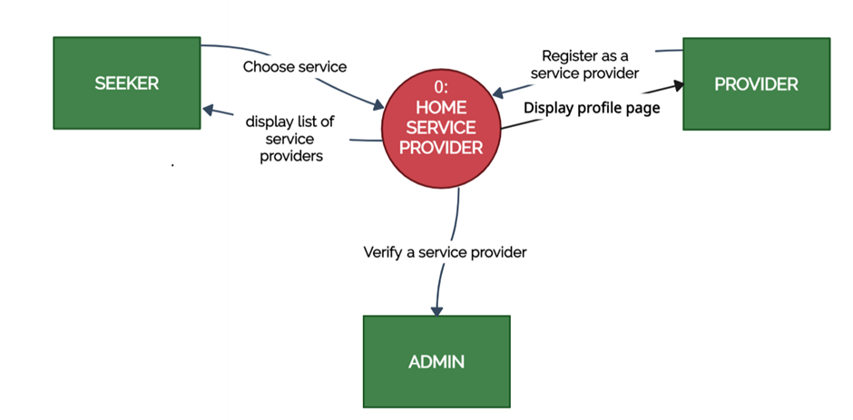

* **DFD Level 1**

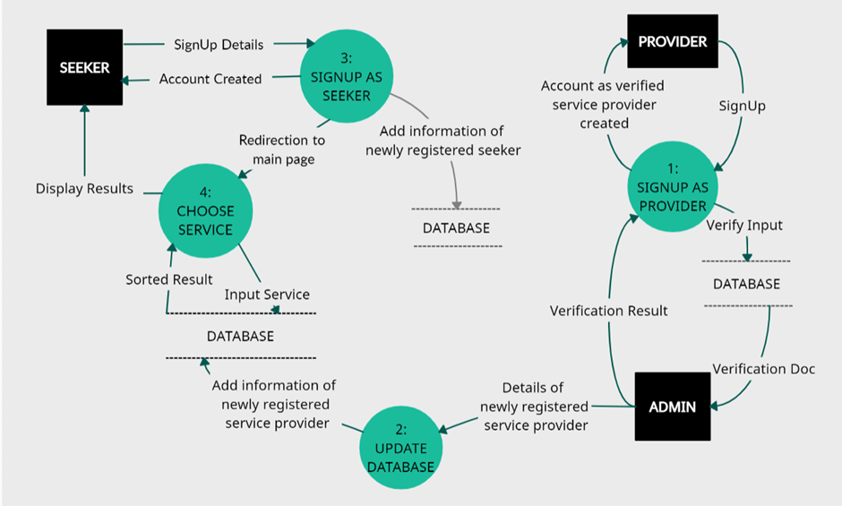

* **DFD Level 2**

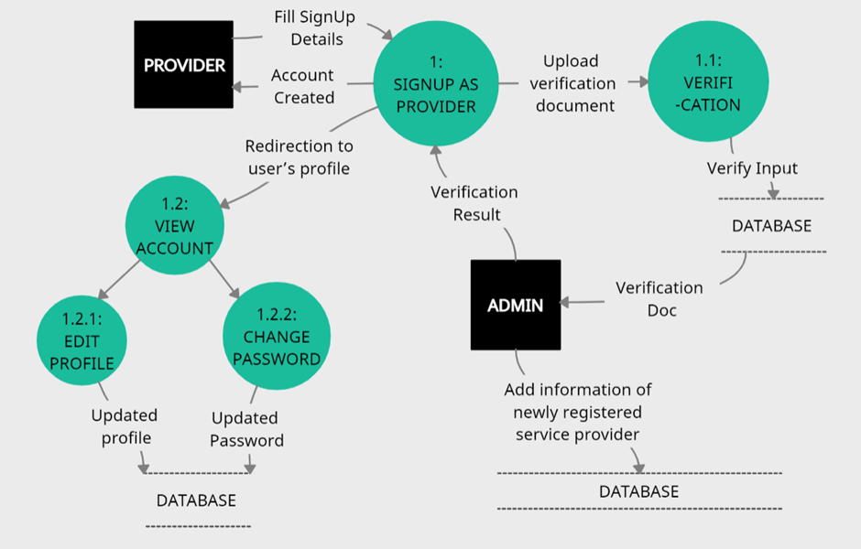

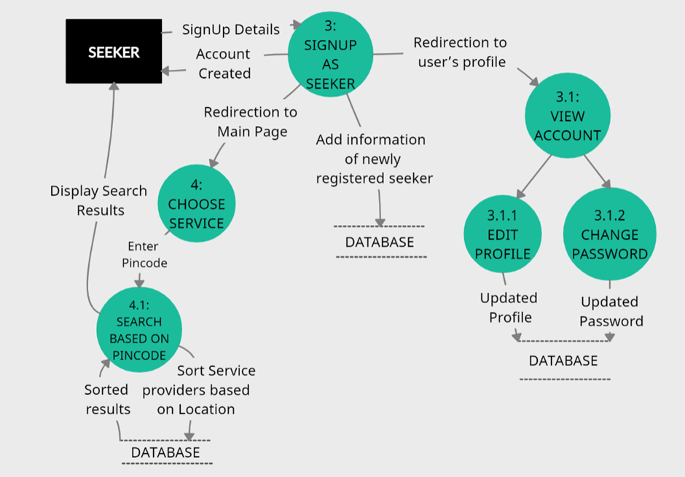

**5. System Specifications**

**a. Software specifications**

1. Node.js (Runtime Environment):
   * Utilized as the backend server environment to run server-side JavaScript code.
   * Facilitates non-blocking, event-driven architecture for efficient handling of concurrent requests.
2. Express.js (Web Framework for Node.js):
   * Framework used to build the web application and manage server-side routes, middleware, and requests.
   * Enables creation of RESTful APIs and handling of HTTP requests and responses.
3. MongoDB with Mongoose (Database):
   * MongoDB is utilized as the NoSQL database to store and manage application data.
   * Mongoose is used as an ODM (Object Data Modeling) library for MongoDB, providing schema validation and simplifying database interactions.
4. Nodemailer (Email Integration):
   * Integrated with Nodemailer for sending transactional emails (e.g., account verification, notifications) from the server.
   * Configured with SMTP transport settings to deliver emails through a mail server.
5. Twilio (SMS Integration):
   * Integrated Twilio API for sending SMS notifications and alerts from the application.
   * Configured with Twilio account credentials to send SMS messages programmatically.

These software specifications outline the foundational technologies and integrations used to develop and enhance the functionality of the website, enabling features like routing, database interactions, email communication, and SMS notifications.

**6. TOOLS USED**

**Selenium:**

Selenium was utilized for automated testing of the website's functionality, including signup form submission, login form submission, forget password functionality, edit-profile functionality, SMS and Email sending functionality and user interaction with the website by submitting inquiries.

**TestNG:**

TestNG is used as the testing framework for organizing and executing test cases. It facilitated test suite management, prioritization of test cases, parameterization of tests, and generation of test reports. TestNG annotations were used for setting up preconditions using @BeforeClass, test execution, and post-validation using @AfterClass.

**7. Screenshots**

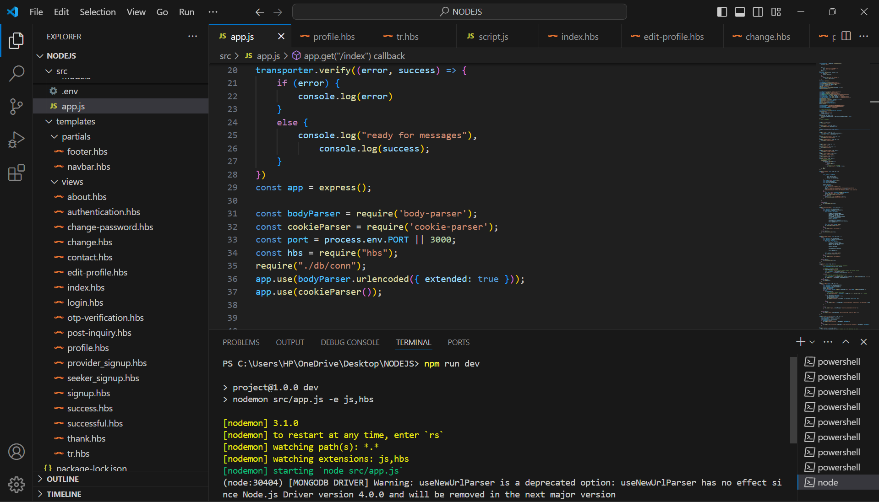

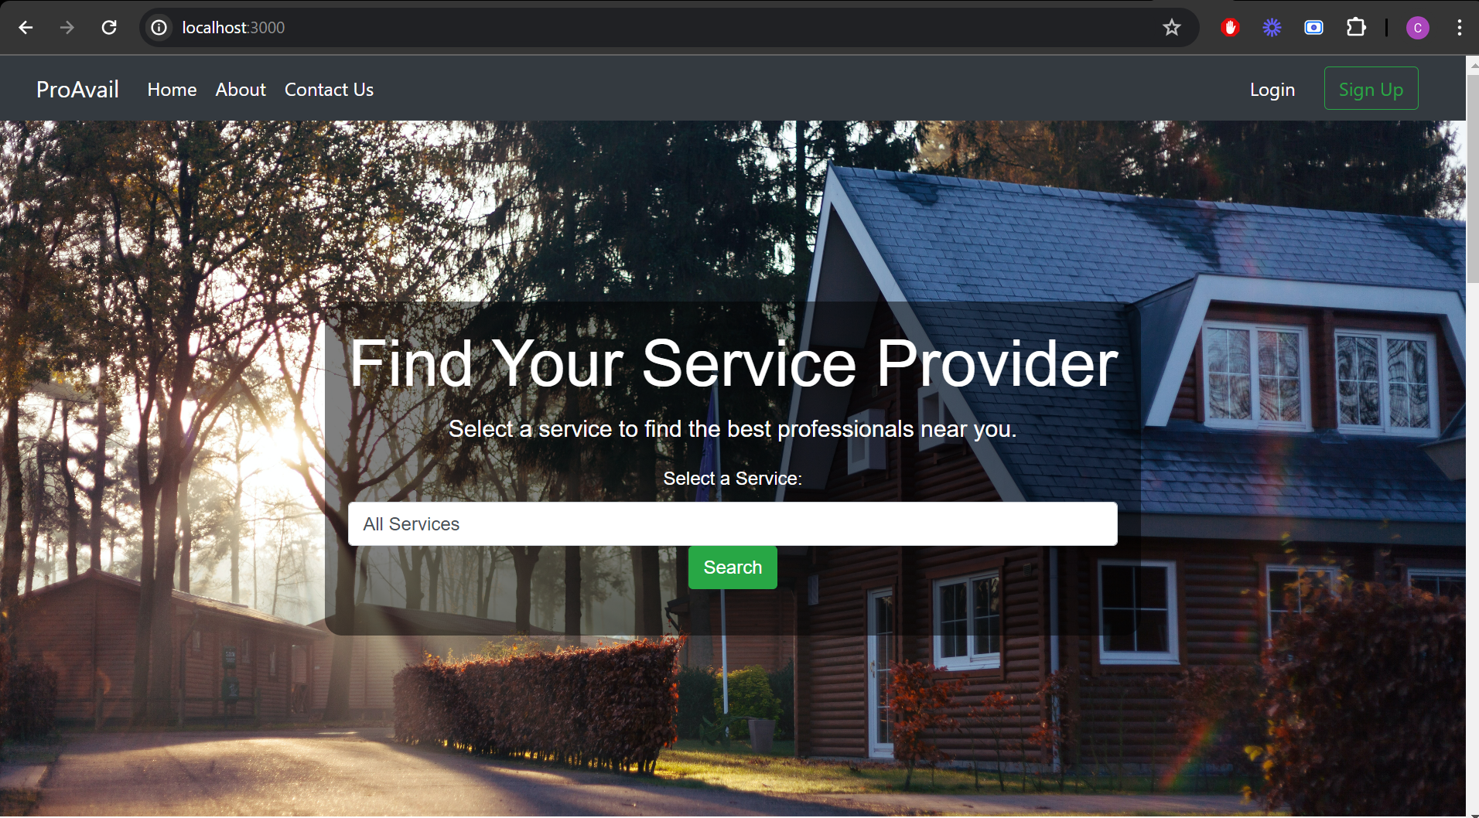

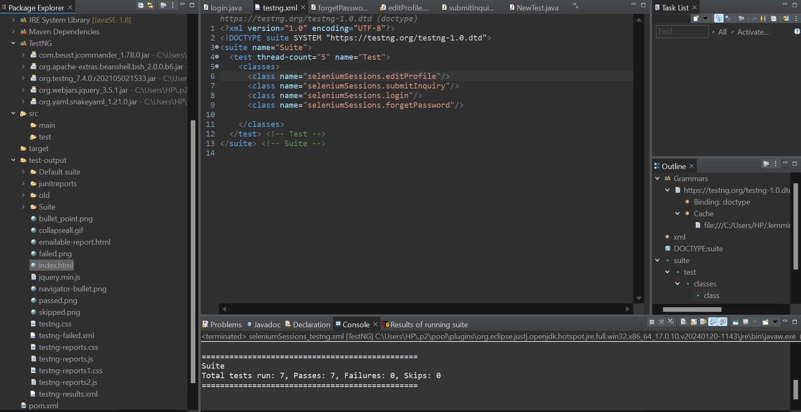

**8. Output Reports**

1. emailable-report.html

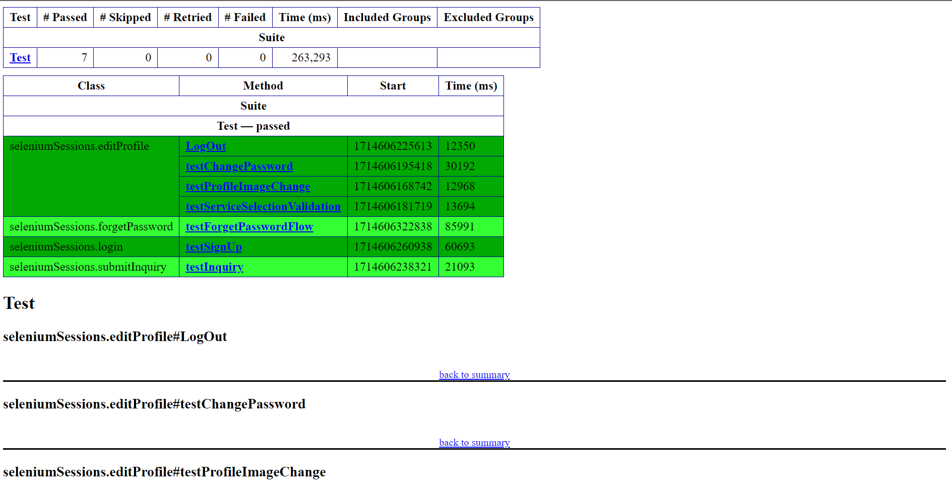

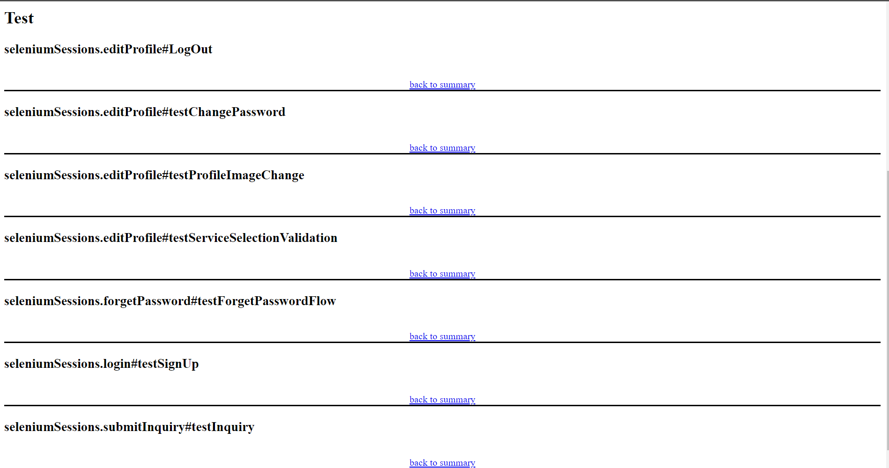

1. index.html

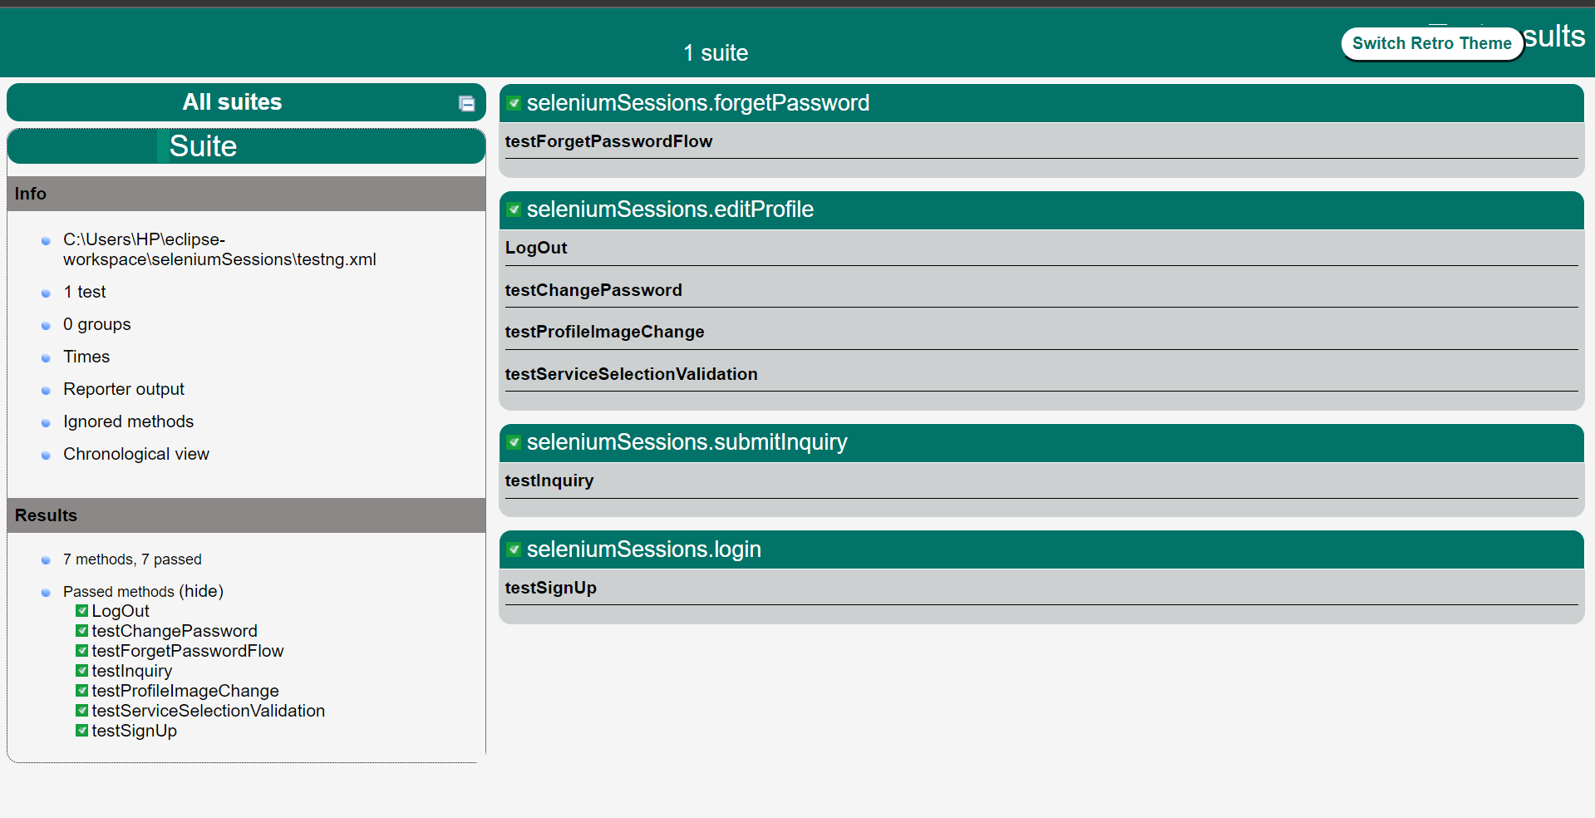

1. XSLT report

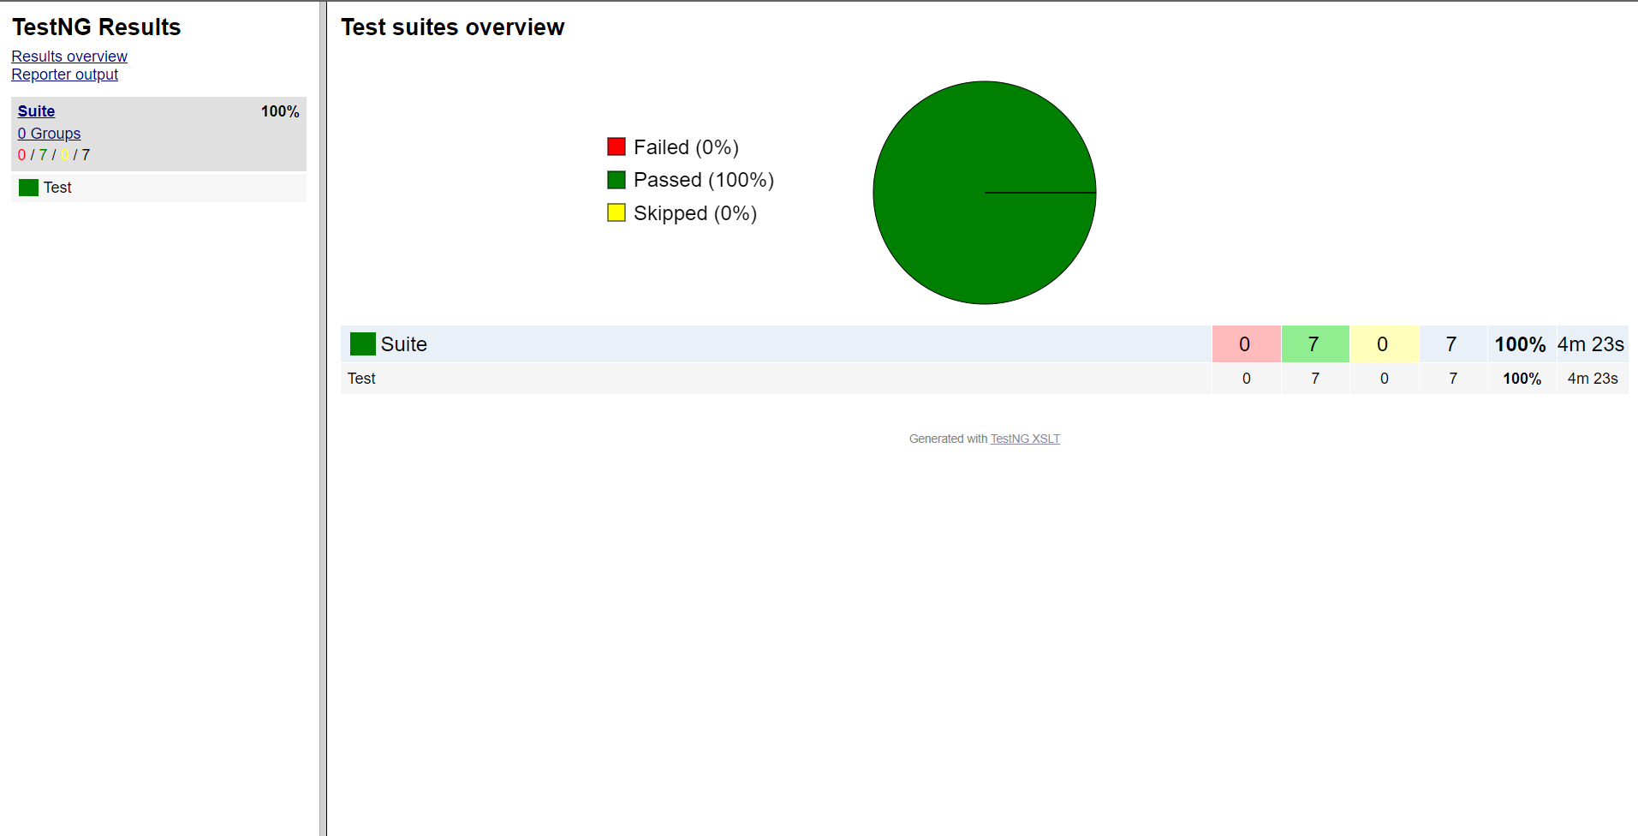

**8. Conclusion**

In conclusion, the development of the home service provider website has been a significant undertaking aimed at creating a centralized platform for connecting service seekers with a variety of professional providers. The project focused on building a robust and user-friendly web application that facilitates seamless interactions between users and service professionals. By emphasizing responsive design, efficient data management, and integrated communication tools, the website offers a convenient solution for accessing and engaging with home services. Moving forward, there is potential to enhance the platform's features and user experience to further optimize accessibility and usability, ensuring its continued value within the home service industry.